Little Falls Township News Update

Little Falls Town Hall & Community Center
March 2021

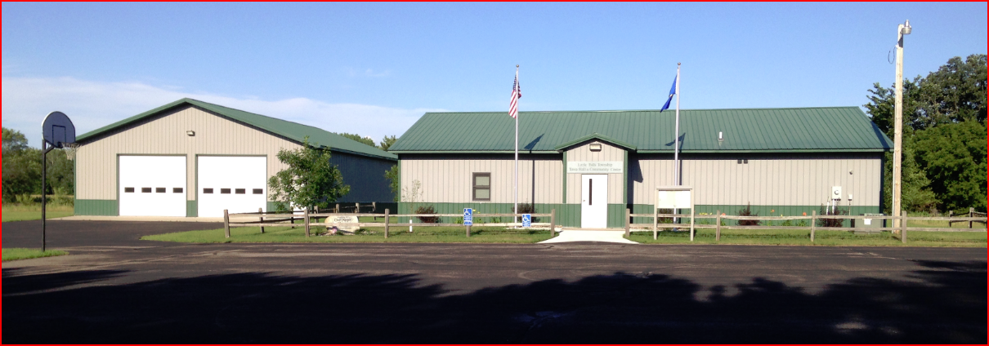

2021 Message from the Little Falls Township Board

Welcome once again to the Little Falls Township (LF TWP) News Update for 2021! As your Township Board, it has again been our privilege to represent you for another year.
At the time of drafting this News Update, our Township and Citizens have endured a year of events not known in this Century. In 2020, the United States and Minnesota was inflicted with the 2019 novel coronavirus outbreak, which became to be known as the COVID-19 virus. On February 11, 2020 the World Health Organization (WHO) announced an official name for the disease that is causing the 2019 novel coronavirus outbreak, first identified in Wuhan China. The new name of this disease is coronavirus disease 2019, abbreviated as COVID-19. In COVID-19, ‘CO’ stands for ‘corona,’ ‘VI’ for ‘virus,’ and ‘D’ for disease. Formerly, this disease was referred to as “2019 novel coronavirus” or “2019-nCoV”. By the near end of February 2021, according to State of Minnesota, Morrison County has recorded 3,256 Total Cases and 47 deaths. The COVID-19 virus essentially changed the way we live, work, play, eat, celebrate and educate to name a few. This virus has wreaked havoc in many differing ways, touching every aspect of our lives throughout the year.
That having been noted, the Township Board is looking forward to much more rewarding year. We as a Board strive to execute our statutory duties in the best possible manner for the public interest and well-being. Correspondingly, we always welcome your feedback and assistance in identifying issues, as well as opportunities to further the goals for the Township and its residents. Please feel free to call us at any time, on any issue in which you may need information or assistance, or have ideas for improvements to our service.
Our positions and phone numbers are provided below for your use as appropriate:
Chuck Parins Supervisor & Chairperson 320-632-2627
John Theis Supervisor & Vice Chairman 320-980-5352
George Sandy Supervisor & Road “Boss” Supervisor 320-630-5595
Bonnie Bieniek Township Clerk 320-360-6342
Joann Sowada Township Treasurer 320-632-5297
Additionally, Jennifer Smude and Carol Doucette serve as the Deputy Clerk and Treasurer respectively.
We also have a great team of part-time employees in Dave Becker (former Little Falls Town Board Chairman and Supervisor), Jerry Smude, and Al Heinz, keep our maintenance backlog at bay throughout the year. Our crew, along with our dedicated contractors (in particular Dave Larson, owner/operator of DLL Excavating, Inc., the TWPs primary contractor), strives to provide quality service and support to the Township.

We also work very closely with our partner governmental units such as the Morrison County (MC) Board of Commissioners, Assessor, Department of Public Works, Land Services, and the Morrison County Soil & Water Conservation District to accomplish the goals of the Township. Without their assistance and support it would certainly be much more difficult to provide the same level of services to our residents. These agencies, coupled with other City governments, Regional and State agencies, as well as mutually supporting organizations help provide effective and efficient processes.

The LF TWP Board’s core missions are to provide for road maintenance services, execute election duties, as well as coordinate and contract for Fire Department services. LF TWP also maintains one (1) very small cemetery. These services intended to benefit Township residents and protect the public's health, safety and welfare. The LF TWP Boards basic tenets are to:
- Provide Appropriate and Sound Technical Solutions for Road Maintenance
- Maximize Value and Cost Effectiveness in Providing Government Services
- Build Constituent Trust and Satisfaction in Execution of Our Missions
2021-2022 Monthly Meetings
The regular monthly meetings are held on the first Monday of each month at 6:30 pm, with exceptions made for the June and December meetings, which start at 5:30 pm (occasionally meetings are rescheduled for observance of Federal Holidays). Meetings are conducted at the Little Falls Township Town Hall and Community Center, located at 15132 Gordon Circle, Little Falls, MN. Meetings are open to the public and Residents can present their issues and voice their opinions at these meetings, but cannot vote at regular monthly or special board meetings. Residents do have the opportunity to submit motions and vote accordingly at the LF TWP Annual Meeting. We request that whenever possible, any person or parties interested in presenting an issue, plan or proposal, contact the Township Clerk or one of the Supervisors to be included on the agenda with as much lead time as possible to ensure that any required action will be able to be completed in as expeditious manner as possible. In the event of a holiday or inclement weather, the meeting will be held on the following Monday. If a meeting is cancelled for any other reason, it will be publicized on KLTF radio and rescheduled and posted in the Morrison County Record in the legal section when time allows. All legal notices are posted on the posting board attached to the Town hall, left hand side of the main entrance. Anyone wishing to be put on the agenda can contact the clerk, by phone, e-mail (littlefallstownshipclerk@yahoo.com), or via letter.
Regular Monthly Meeting Dates for April 2021 – March 2022:
April 5, 2021 May 3, 2021 June 7, 2021 (5:30)
July 12, 2021 August 2, 2021 September 13, 2021
October 4, 2021 November 1, 2021 December 6, 2021 (5:30)
January 3, 2022 February 7, 2022 March 7, 2022
* Please note that the final Regular Monthly Meeting Dates are finalized at the Little Falls Township Board’s Special Board (Reorganizational) Meeting conducted on March 15, 2021.
** Also, please note that the June and December meetings are the original “Town Hall Meetings”, where we invite our State Government’s Senator and local Representative, County and Regional Officials, as well as our business partners to attend our meeting and participate in a forum for conversation with our residents about our State and Local governance, as well many other topics of interest to our constituents. This forum for conversation is provided in both a formal (during the public meeting) and informal atmosphere, where after we adjourn we typically share a light meal together and gather socially. We currently have invites into Senator Gazelka and Representative Kresha’s Offices for the June 7, 2021 Township Meeting. However, as LF TWP remains vigilant with respects to the status of the pandemic, we recommend all Township Residents please watch for continuing changes due to the Governor’s peacetime emergency declarations about the threats of the COVID-19 pandemic. Local government units must adhere to the guidelines established. Check with your Township Officials for updated guidelines if you intend to attend any of the Township public meetings in person.
2020-21 Township Projects & Proposals
- Elections. The LF TWP Board made a conscious decision to conduct the Presidential primary and election in person during November, 2020. As a resident of Little Falls Township, we believe we provided the necessary precautions at the Little Falls Township Town Hall and Community Center to vote in a safe and effective manner. It is the Board’s intent to continue to conduct in-person elections whenever possible, however, Residents are always afforded the opportunity to request an Absentee Ballot. Voters will be asked to adhere to the social distancing recommendations by the Center for Disease Control (CDC) and other health department recommendations. While sanitation products will be copiously used to clean and disinfect frequently touched surfaces throughout the Town Hall, it is always encouraged that Voters please feel free to bring and use their own personal protective equipment (PPE) and sanitation products with them to complement their own personal level of safety while voting within the Town Hall.
- Little Falls Township Comprehensive Plan Update. In 2020, LF TWP, coupled with the Steering Committee, updated the Little Falls Township Comprehensive Plan. A Public Informational Meeting was conducted, a Steering Committee was established, and meetings were being conducted on a monthly basis until the pandemic situation created a hiatus in the progress. The Steering Committee consisted of Gen Young, Greg Smith, Randy Tabatt, Richard Kliber and Kelly Theis. We did move forward however, and solicited Resident input through our Community Survey to finish this work. 745 Households were sent the Survey and 198 were returned. The Survey is considered a phenomenal success with the approximate 27% return rate and many recorded comments. Results of the Survey are available to anyone in the Township when in a published format and will be provided on the Township Website as well. This Survey’s results will be used in part to guide Little Falls Township’s decision making and development into the future. The goal of completing the Comprehensive Plan was realized in December 2020. This 2020 plan will assist in driving future development, and preservation efforts, by serving as a guide for future ordinance amendments and rezoning requests. However, there is still much work to be accomplished with regards to continuing to enhance the Comprehensive Plan and realize this document will ultimately be a living document as State and County requirements change into the future. This 2020 plan will drive future development, and preservation efforts, by serving as a guide for future ordinance amendments and rezoning requests.

2021 Township Clean Up Day
The Township Clean-Up Day for our Township residents this spring will be held on Saturday, May 1st, 2021, from 8:00 am to 11:30 am. The Morrison County Department of Public Works has been sponsoring a portion of this service with grant money, coupled with a portion of Township Funds to provide this yearly service. More information will be publicized in the MC Record. Residents will be asked to adhere to the social distancing recommendations by the Center for Disease Control (CDC) and other health departments.

Little Falls Town Hall and Community Center Rental
The Little Falls Township Hall and Community Center remains available for rent to the Residents of Little Falls Township at a rate of $75 per day, with a deposit of $200. Please contact Township Supervisor John Theis, who manages the rental calendar or one of the other Township Supervisors or Board Members for more information and reservations.

Little Falls Township Web Site
As a reminder, we encourage our Residents to take an opportunity to peruse the web site for their awareness, but moreover, to provide feedback to the Board on ways to improve the site. Much of the public information pertaining to Board contact information and day-to-day business information and documents can be found on the organization’s web site, located at http://www.littlefallstownship.com/, where agendas, meeting minutes, permit & rental forms, as well as public notices can be found for constituent and public use.

Little Falls Township Board of Audit
Little Falls Township Board conducted its Annual Board of Audit on February 22, 2021. The 2020 documents of record were reconciled against all 2020 checks, check registers and bank statements. The funds registers and accounting documents were methodically compared. All funds balanced, and where discrepancies were identified (primarily due to bank statement errors), all were subsequently resolved. No shortages or overages were noted. A copy of the Board of Audit results is provided below on the next page and additionally available for examination and publicly posted during the Annual Meeting.

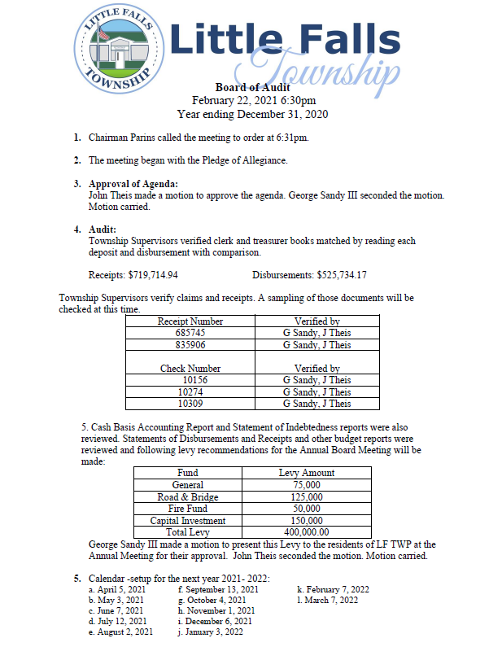

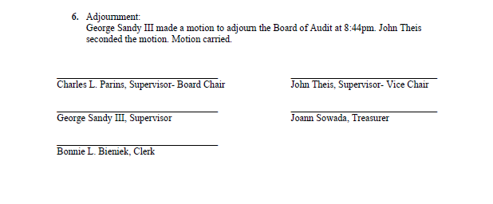

Thank You!
We, your elected officials of Little Falls Township, would like to thank all of the Residents for the support given to us through an unprecedented 2020 year. Without your input at monthly meetings, assistance and support, we would not be able to do our job. All meetings are open to the public, unless specifically closed because of Privacy Act requirements.
Chuck Parins, Supervisor and Editor
Property Taxes and Setting the Town Levy
Property taxes constitute the primary source of revenue for Town Government. The electorate sets the Town’s property tax levy at the Annual Town Meeting. The Town Clerk then certifies the amount of the levy to the County Auditor annually by September 15th. The Town Levy may only be set at a Town meeting. The Little Falls Township Board proposes to keep the levy at the same level as last year. It should be noted that the Little Falls Township Market Value is estimated to increase approximately over $39.6 Million Dollars from 2017 to 2021. Correspondingly, the percent levy against the 2021 Township Market Value under the proposed levy, remains below 0.20 hundredth of one (1) percent.

Little Falls Township Budget and Levy Proposal

ACCOUNT | 2018 Budget | 2019 Budget | 2020 Budget | 2021 Budget | 2022 Proposal
GENERAL REVENUE FUND | $45,000 | $60,000 | $80,000 | $80,000 | $75,000
FIRE FUND | $35,000 | $20,000 | $20,000 | $40,000 | $50,000
ROAD & BRIDGE FUND | $125,000 | $125,000 | $125,000 | $125,000 | $125,000
CAPITAL INVESTMENT FUND | $125,000 | $125,000 | $165,000 | $155,000 | $150,000
TOTAL REVENUE | $330,000 | $330,000 | $390,000 | $400,000 | $400,000
 | 2017 | 2018 | 2019 | 2020 | 2021
Township Market Value | $176,260,000 | $181,287,900 | $197,606,300 | $212,810,400 | $215,912,700
% Levy  vs.  TWP Market Value | 0.19%  (0.00187) | 0.18%  (0.00182) | 0.20%  (0.00197) | 0.19%  (0.00187) | 0.19%  (0.00185)

Township levies for the following year are approved at the current year’s Annual Town Meeting, meaning that the levy is set nearly a year in advance, and when collection and payment dates are factored in it becomes apparent that towns essentially need to plan their budgets and levy needs two years in advance.

Provided below is the status of the Township’s funds balance, as well as a recap of the major disbursements authorized throughout year 2020:
ANNUAL STATEMENT of the TREASURER of LITTLE FALLS TOWNSHIP for 2020
BEGINNING ACCOUNT BALANCE ON JANUARY 1, 2020 $301,180.33
INCOME:
Morrison County Treasurer: Tax Settlement, Gas Tax Revenue, PILT and Solid Waste/Landfill Surcharges/Licenses | $393,365.21
State of Minnesota: Ag Credits, PERA Aid Credits, Ag. Credit, HSEM, CARES Act and Aid Credits | $107,700.07
Interest: Bank Interest $1,242.68; Savings/CD Interest $5,069.28 | $6,311.96
Charges for Services & Permits – Title Searches; Utility Permit Fees | $1,090.94
Line Road Maintenance Reimbursed by Belle Prairie ($3,625.08), Bellevue ($9,002.20) & Agram ($1,665.94) TWPs | $14,293.22
Town Hall Rentals (Note $775.00 damage Deposits Refunded) | $825.00
Resident Reimbursement for Calcium Chloride Application | $1,027.73
Road Access Permit Deposits -- @ $200.00 each. Refunded After Satisfactory Completion | $655.00
Clean-Up Day – Additional Charges | $104.00
Income from CD | $125,000.00
Miscellaneous Income | $243.27
TOTAL INCOME | $650,616.40
Transfers: | $00.00
Certificates of Deposit (NOTE: Total Current Savings in CD’s - $275,000.00) | $275,000

DISBURSEMENTS BY FUND:
General Revenue Fund | $95,725.29
Fire Fund | $43,036.88
Road & Bridge Fund | $106,804.50
Road Allotment | $41,681.27
Solid Waste/Landfill Host Fee Fund | $9,331.80
Capital Investment Fund | $229,154.43
TOTAL DISBURSEMENTS | $525,734.17
ENDING FUNDS BALANCES: CHECKING ACCOUNT, $495,161.10 SAVINGS ACCOUNTS, $275,000.00
ENDING ACCOUNT BALANCE ON DECEMBER 31, 2020 $770,161.10
MAJOR DISBURSEMENTS (Not all inclusive):
Fire Protection; City of Little Falls - $41,370.56, includes other $255.00 (Fire Extinguisher Services) | $41,370.56
Donations set by the Residents at the Annual Meeting | $9,150.00
DL&L Excavating for Snowplowing, Sanding, Blading, Gravel and Graveling Roads | $75,752.58
Knife River – North Central to apply Calcium Chloride and Road Work—Paving & Tar Patch | $137,038.50
Anderson Brothers. Crack and poly patch | $38,985.25
Festler Land Survey – staking road center | $650.00
Greg Colombe for Roadside Mowing | $2,400.00
Morrison County Department of Public Works: Winter Sand, Culverts, Mailbox Stands, etc. | $8,613.87
Doucette Landscaping & Construction establish turf& erosion control | $7,267.00
Town Board and Employee Salaries – Labor, Training, and Supplies | $32,647.45
Election Expenses for TWP Elections --- Judges including training $607.92; Ballots & Auto Mark 275.50 | $883.42
Insurance $5,799.00; Dues $934.28; IRS $5,221.40 | $11,954.68
Gopher Bounty ($1,060.50); MC Animal Humane Society ($1,947.00) | $2,298.50
Clean-Up Day: Bob LeMieur Roll-Off dumpster & Tire disposal $2,162.40; MC E-waste $1,180.09 | $3,342.49
Legal Services | $4,004.00
Land and ROW Purchase for New Road | $46,000.00
West Bend Electric New Shed Door Openers | $941.04
Midwest Machine new John Deere Lawn Mower | $2,911.78
Britz Store New Commercial Grade Refrigerator | $941.04
Town Hall: Crow Wing Power, $864.00; Federated Co-ops for propane $906.74 | $1,770.74
Kingsway Cleaning Service,$1,400.00; Spectrum Business Internet & WIFI, $1,054.76 | $2,454.76
All Other Disbursements | $17,052.13
TOTAL DISBURSEMENTS, $525,734.17

Little Falls Township News Update March 2021

2021 Annual Road Report
Road Maintenance Synopsis
2020 was another busy year for Little Falls Township for road maintenance. First of all, I would like to thank the contractors that keep our township roads in great condition. DLL Excavating, Dave Larsen, was responsible for blading, snowplowing, and sanding our roads as well as miscellaneous projects such as culvert replacement, right of way reshaping, and gravel application. Anderson Brothers, Jerry Beckman, provided our tar road maintenance, mainly crack patching. This is very important because it extends the life of our tar roads to 20 years. Tim Otremba and Adam Surma of Knife River did all of our tar overlays this past year and applied calcium chloride on various roads.
Crack patching on various roads was completed by Anderson Brothers. These roads were selected by age and need of the road. Normally these roads would be 1-5 years since they were last paved. In 2020 we did crack patching on Harvest Road, Edgar Drive, 123rd Street west of US 10 and several locations on Timberlost and Ramsey Lane. The total spent on crack patching was approximately $13,000.
Knife River Corp. overlayed 2.5 miles (1.5 miles Little Falls Twp, 1.0 miles Bellevue Twp)of 170th Avenue for us in May. DLL Excavating did the shouldering and Sir Lines A Lot applied the paint striping. Total cost for Little Falls Twp. portion was approximately $165,000. Knife River also did our calcium chloride application in May for approximately $18,000 for 4.5 miles some of which was reimbursed by Belle Prairie Township. This is down by 2 miles from previous years.
DLL Excavating applied gravel in 2020 to the gravel portion of Harness Road, Grouse Road and 118th Street east of Iris Road. They also did an excavation on Skyview Ridge Road on a 150 foot area that was sliding down the hill, reshaped north right of way and cleaned a culvert in preparation for a 2021 bituminous overlay. DLL was also our primary contractor for flood repairs on the 10 inch rain event Little Falls Township experienced in late June. The area west of US 10 was the hardest hit. We had to replace 5 washed out culverts in this area. Other roads that had minor to moderate damage were Harness Road, 170th Avenue, 180th Avenue, and 153rd Street. Total flood repair/mitigation costs were approximately $70,000 of which $56,000 were reimbursed by the State of Minnesota, as we were declared a disaster area.
For the calendar year 2020, Little Falls Township spent $364,000 on road and right of way maintenance keeping in mind that we received a $56,000 flood repair reimbursement from the State. Included in the total is snow plowing and road grading. Going forward into 2021, plans are a bituminous overlay on Skyview Ridge Road and a 3,000 foot area on the worst portion of 140th Avenue, replace culverts and apply 3-4 inches of gravel on 180th Avenue north of MN 27 and about 3,000 feet of the easterly portion of 153rd street that connects to 180th Avenue. We will also crack patch our 2019 paving projects, Angelina Drive, Wooddale Drive and Hidden Acres Drive. Little Falls Township Supervisors would like to thank our constituents for their continued support and look forward to working with you going forward.
Respectfully submitted, George Sandy III,-Road Supervisor

